

**ABBOTTABAD UNIVERSITY OF SCIENCE AND TECHNOLOGY ABBOTTABAD**

**NAME : Sayyed Zain Ul Abidin Shah**

**SUBMITTED TO: Sir Jamal Abdul Ahad**

**ROLL NO : 1237**

**SUBJECT : DSA**

**DATE OF SUBMISSION : 13 Nov. 23**

**Q1: Design a Python program that simulates a web server handling incoming requests using a queue. Model different types of requests with varying processing times and simulate their processing order.**

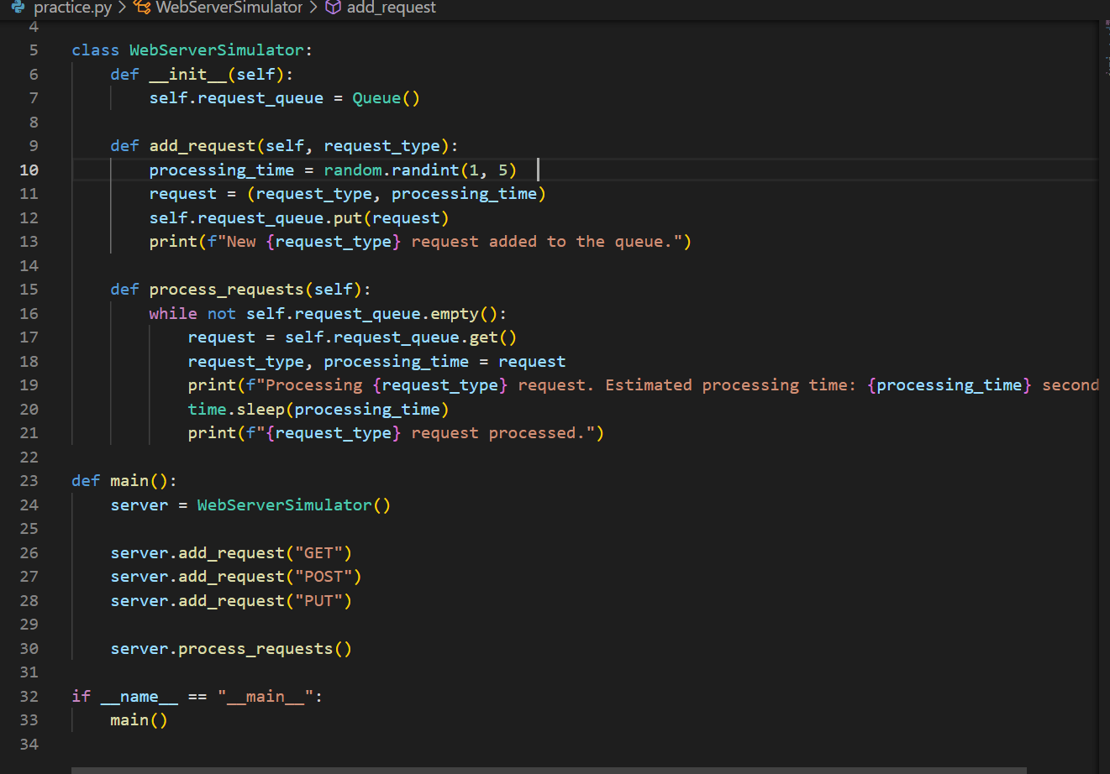

**Q2: In what scenarios would you choose a linked list implementation over an array implementation for a queue, and vice versa?**

**ANSWER:**

Choosing between a linked list implementation and an array implementation for a queue depends on the specific requirements and characteristics of the application. Both data structures have their own advantages and disadvantages. Here are scenarios where you might prefer one over the other:

**Linked List Implementation for a Queue:**

1. **Dynamic Size:**

- Linked lists are more suitable when the size of the queue is dynamic and can change frequently. Since linked lists can easily grow or shrink, they are convenient when the number of elements in the queue is unpredictable.

2. **Frequent Enqueue and Dequeue Operations**:

- If your application involves frequent enqueue and dequeue operations and the size of the queue is not fixed, a linked list is a better choice. Adding or removing elements from the front or back of a linked list is O(1) in time complexity.

3. **Memory Efficiency:**

- Linked lists are more memory-efficient than arrays when it comes to dynamic memory allocation. Linked lists only use as much memory as needed for the elements.

4. **No Pre-allocation:**

- In scenarios where you don't want to pre-allocate a fixed amount of memory for the queue, a linked list allows you to use memory as needed.

**Array Implementation for a Queue**:

1. **Fixed Size Queue**:

- If the size of the queue is fixed or can be estimated in advance, using an array might be more appropriate. Arrays provide constant time complexity for random access, making them suitable for scenarios where indexing is important.

2. **Cache Locality:**

- Arrays generally have better cache locality compared to linked lists. If your application involves frequent access to elements and you want to take advantage of cache performance, an array may be a better choice.

3. **Simpler Implementation**:

- If simplicity is a priority and the size of the queue is known and fixed, an array implementation might be easier to implement and manage.

4. **Lower Overhead:**

- Arrays have lower memory overhead compared to linked lists. Each element in an array requires less memory compared to an element in a linked list node.

**Common Considerations:**

1**. Random Access:**

- If random access to elements (accessing elements by index) is a requirement, an array is more suitable. Linked lists do not provide direct access to elements by index; you have to traverse the list.

2. **Complexity and Overhead:**

- Consider the overhead associated with each data structure and the complexity of the operations you'll be performing. For example, inserting or deleting elements in the middle of an array can be inefficient.

**Q3: Discuss the time complexity of enqueue and dequeue operations in a basic queue. How can you optimize these operations for specific use cases?**

**ANSWER:**

In a basic queue, the time complexity of enqueue and dequeue operations depends on the underlying data structure used to implement the queue. Two common implementations are array-based queues and linked list-based queues. Let's discuss the time complexity for each operation in both scenarios:

**Array-Based Queue:**

1**. Enqueue Operation:**

- Enqueuing an element in an array-based queue involves adding an element to the rear (end) of the array.

- Time Complexity: O(1) on average. However, if the array needs to be resized (when it becomes full), the enqueue operation can take O(n) time, where n is the current size of the array.

2. **Dequeue Operation**:

- Dequeuing an element from the front of the array involves shifting all remaining elements to fill the gap.

- Time Complexity: O(n) in the worst case, where n is the current size of the array. On average, it's O(1) because most dequeues do not trigger a shift.

**Linked List-Based Queue:**

1. **Enqueue Operation**:

- Enqueuing an element in a linked list-based queue involves adding an element to the rear (end) of the linked list.

- Time Complexity: O(1). Linked lists excel at constant-time insertions at the beginning or end.

2. **Dequeue Operation**:

- Dequeuing an element from the front of the linked list involves removing the first element and updating the front pointer.

- Time Complexity: O(1). Similar to the enqueue operation, linked lists allow constant-time removals from the beginning.

**Optimization for Specific Use Cases:**

1. **Array-Based Queue**:

- To optimize enqueue operations, you can use a circular buffer or circular array. This way, when the rear pointer reaches the end of the array, it wraps around to the beginning, avoiding the need for shifting elements.

- To optimize dequeue operations, you can periodically resize the array or use a dynamic resizing strategy to maintain a reasonable ratio of used to unused space.

2**. Linked List-Based Queue**:

- Linked lists naturally support constant-time enqueue and dequeue operations. Additional optimizations may involve using a doubly linked list to allow constant-time removal from the end of the list as well.

3. **Hybrid Implementations**:

- In some cases, hybrid implementations, such as using a dynamic array that occasionally gets resized, can offer a good balance between the advantages of arrays and linked lists.

4. **Preallocating Sufficient Space:**

- If the maximum size of the queue is known in advance, preallocating sufficient space for an array-based queue can minimize resizing and improve performance.

**Q4: How can you use two stacks to implement a queue? Provide a step-by-step explanation of the enqueue and dequeue operations in this scenario.**

